**VIJAY KUMAR**

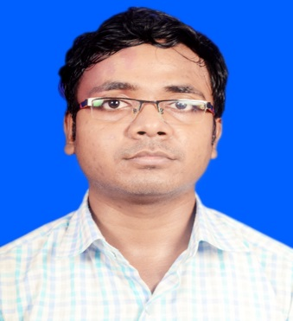

|  |  |
| --- | --- |
| **Title:** | **Analyst/Software Engineer** |
| **Location:** | Dhanbad, Jharkhand |
| **Languages:** | English (fluent), Hindi (native) |

# Experience Summary

The full stack development training at Capgemini provided a nice project exposure and enhanced the development skills. Quikr project was developed using agile methodology and an end to end application was delivered in which the front end validations were done using Angular JS which connected to the Spring Boot application for the backend implementation and that would also interact with the NOSQL database MongoDB.

**KEY SKILLS:**

* **Functional:** Excellent time management, Project Management, Problem Solver, Team Building, Strategic/Tactical Planning
* **Technical:** Core Java, Selenium, Advanced Java, Spring framework, Spring Boot, Micro services, Angular 7, Mongo DB, JavaScript, SQL, HTML, CSS.

# Experience

Developed a Quikr application using micro services architecture and spring boot in the back-end and angular as front-end technology.

|  |  |  |
| --- | --- | --- |
| **01** | **Type of Industry:** | Software Development |
|  | **Project Description:** | An end to end application for an ecommerce website using micro services architecture using spring boot and various spring features like spring security, swagger, Mockito, Hystrix and spring cloud interacting with the database Mongo DB. |
|  | **Role/Title:** | Java Developer |
|  | **Project Duration:** | 3 weeks |
|  | **Responsibilities:** | * Created model, repository, services and controller classes for each Microservices using Spring Boot and MongoDB. * Implemented Spring Security, Hystrix and Swagger. * Implemented Spring Cloud by including Eureka Server, Netflix Zuul. |
|  | **Operating Systems:** | * Integrated Angular JS and spring boot micro services. * Integrated database and spring boot.   Windows 10 |
|  | **Software / Languages:** | Java, Angular 7, MongoDB, Type Script,HTML. |
|  | **Special Tools:** | Spring Tool Suite, Postman, RoboMongo |

# Training, Certifications & Affiliations

* Full stack development training from Capgemini.

# Higher Education

* Guru Gobind Singh Public School, Dhanbad (S.S.C.)
* KIIT Science College, Bhubaneswar (H.S.C.)
* Kalinga Institute of Industrial Technology, Bhubaneswar (B.E)